August 26, 2016

The Honorable Edmund Gerald Brown, Jr.
Governor
State of California
State Capitol Suite 1173
Sacramento, CA 95814
Dear Governor Brown:
Safe Kids Worldwide strongly supports AB2007, which would apply the state’s smart return-to-play concussion laws to community-based sports leagues for young athletes. We applaud the legislature’s leadership on this issue and your deep sensitivity for keeping California kids safe. Please sign AB2007 into law.
Everyday, nationally, 1,500 kids are taken to emergency rooms because of a brain-related injury. Presumably, a good number of them were playing sports in a non-school related program. That is why it is cited as a top ten issue of the respected California Unintentional Prevention Strategic Plan Project.
The nation is concerned about concussions involving athletes, ranging from professional players to a middle school aged kid playing a club sport like little league or Pop Warner football. That worry is having a negative effect. At least 2.6 million fewer children participated in sports between 2008 and 2013 according to research by the Aspen Institute’s Project Play. Twelve percent fewer kids are playing soccer, and there’s an almost a seven percent reduction in kids playing basketball. We need to give parents a new level of confidence that they will not be at a serious injury.
How are we doing that? It was a significant advance when California passed its concussion law including the return to play protocol, alongside a coaching training program and informed consent by parents and kids in interscholastic athletics. And the state has gone farther by limiting contact practice, among other measures. Passage of AB2007 would be another important advance by extending return to play to kids involved in non-school sports.
Return-to-play laws are relatively new, but there is evidence they are working. A study published in the JAMA Pediatrics looked at states with the return-to-play laws in place, and those which had not implemented the law: there was a 17% greater health care utilization rates involving concussions in the states with laws in place compared to those without one. Put simply, many more young athletes are being treated for concussions because of the return to play law.
The return-to-play protocol is important, and we favor AB2007 because it includes three additional provisions:
- It requires non-school sports coaches to receive education on the signs and symptoms of a possible concussion. This can be satisfied without additional cost through the CDC’s Heads Up education program.
- It extends the law to all youth non-school sports up to age 19.
- It requires that one individual has the responsibility to ensure that the law is being complied with.

Safe Kids is a network of organizations dedicated to protecting kids from unintentional injuries, the number one cause of death to children 19 and under in the United States. We have a strong presence in California, led by Safe Kids California, and 15 coalitions throughout the state.
We you to sign AB2007 into law to grow the number of young athletes who will be protected under the umbrella of California strong set of child safety laws.
Sincerely,

Safe Kids California, Helen Arbogast
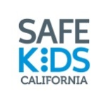
Safe Kids Los Angeles West, Chantel Ponder
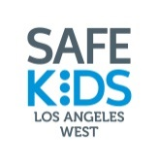
Safe Kids Central Valley, Kristina Pasma
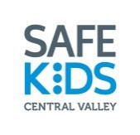
Safe Kids Inland Empire, Michelle Parker
Safe Kids Orange County, Amy Frias
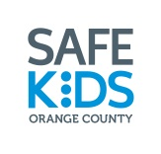
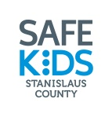
Safe Kids Stanislaus, Rena Lepard
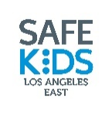
Safe Kids Los Angeles East, Bernadette Rodguez

Contact:
Helen Arbogast, Coordinator
Safe Kids California
Children’s Hospital Los Angeles
harbogast@chla.usc.edu
323.361.2697

